**1**

**INTRODUCTION**

**1.1 OPTICAL BEAM**

The function of optical beam control is to meet the requirements of optical beam for pointing, pointing stability (jitter), quality of optical beam, slew maneuver, object sensing, and tracking. It is a multidisciplinary field consisting of optics, control theory, structures, thermal analyses, vibrations, atmospheric turbulence, and lasers. This is a broad field, and this book will cover fundamentals of each area with applications to imaging satellites and laser systems.

Figure 1.1 shows the range of electromagnetic wave frequencies and wave lengths.

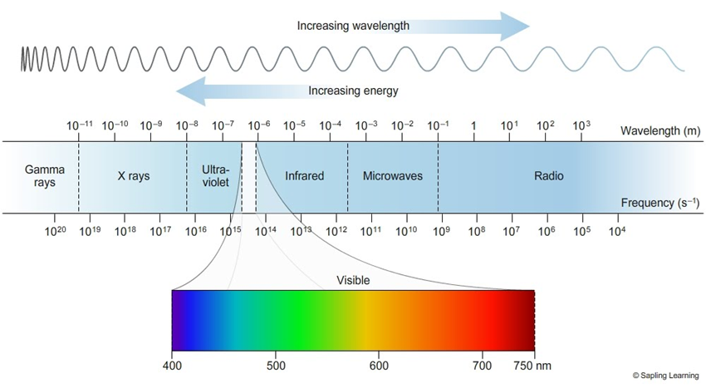

**Figure 1.1.** Electromagnetic Wave Frequencies and Wave Lengths

Source: © Sapling Learning. Reproduced from <Please indicate the exact URL from where this image was reproduced>.

The wavelengths of our interest are primarily in visible range, 400-700 nm and near infra-red range 700-1.100 nm. Because of small wavelengths, the requirements are challenging to meet, for example, typical telescope beam widths are 3-5 microrad. To mitigate most of pointing loss, beam jitter should be less than 30% beam width, resulting in 0.9-1.5 microradian, pointing accuracy should be 0.1 times beam width, resulting in 0.3-0.5 microradian, and optical beam wave quality, wavefront RMS error should be less than, wavelength/30, 30 nm for visible range. These requirements are verry challenging and require state-of-the-art technologies to meet these performance requirements. For electromagnetic waves with larger wave lengths, such as radio waves with several order of magnitude lager wave lengths, pointing, pointing stability, and beam quality requirements will be much easier to meet in comparison with optical beams.

Laser is an acronym for Light Amplification by Stimulated Emission of Radiation. Ordinary visible light, say from a household light bulb or a flashlight, comprises multiple wavelengths, or colors, and are incoherent, meaning the crests and troughs of the light waves are moving at different wavelengths and in different directions. In a laser beam, the light waves are “coherent,” meaning the beam of photons is moving in the same direction at the same wavelength.

Laser light can travel hundreds of meters without being scattered. Since ordinary light is diffused, it cannot focus on a sharp point. Laser light can focus on a point with high intensity thanks to its directional structure. The intensity of ordinary light decreases rapidly with distance. For this reason, you can look at the ordinary light source without harming the eyes. In contrast, laser light is emitted in a narrow beam. Since the energy is concentrated in a very narrow area, looking at the laser light with the naked eye can damage the eye.

**1.2 TELESCOPES**

Most telescopes used by astronomers are on Earth. We call these ground-based telescopes. It is much easier and cheaper to build a telescope on Earth than in space. It is also much easier to fix if things go wrong. However, there are downsides as well. A telescope on the ground must look through the Earth's atmosphere to see into space. This is a problem because the atmosphere can blur our images.

The air, as shown in Figure 1.2 also blocks out light from parts of the electromagnetic spectrum like x-rays, gamma rays, infra-red and long radio waves. This means even if we have the right kind of telescope, it cannot see this type of light from Earth. The air gets in the way. That is why some telescopes are in space.

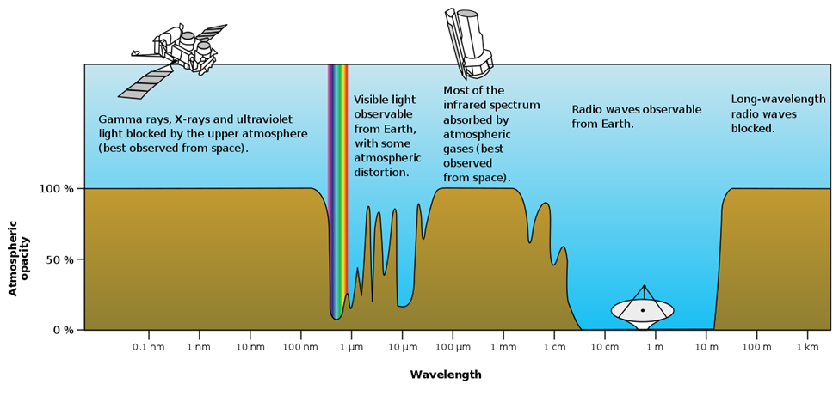

**Figure 1.2.** Atmosphere Opacity of Electromagnetic Waves

Source: © xxxxxxxxx. Please indicate the exact source from where the image was reproduced.

We call the parts of the light spectrum that can get through the air atmospheric windows. These are the parts of the electromagnetic spectrum where the opacity (how much light is blocked) is close to 0%. If the opacity is 100%, then no light with that wavelength can get through the air to reach the ground.

Building and using a space telescope is a huge challenge. It also costs a lot of money. It has only been possible since the 1980s. The first space telescope was the Hubble Space Telescope. It began observing in 1990. It has taken over one million images so far.

Since 1990 there have been lots of other space telescopes. Some collect light which the Earth's atmosphere blocks out. Like Chandra which observes in x-rays and Fermi which looks at gamma rays. Others can see microwaves or infrared. This has given us a new view of our Universe. The largest, James Webb Space Telescope, was launched on December 24, 2021.

**1.2.1 Space Telescope**

Space telescopes have made many fantastic discoveries. Kepler found thousands of exoplanets. Spitzer was the first to image light from an exoplanet. Gaia observed a supernova outside the Milky Way. In the future, LISA will try to detect gravitational waves in space.

Imaging satellites have been used for many civilian, scientific, and military applications looking towards Earth and space. Here we will briefly discuss Hubble Space Telescope and James Webb Telescope. Both were developed for NASA for scientific research of planets.

**Hubble Space Telescope**

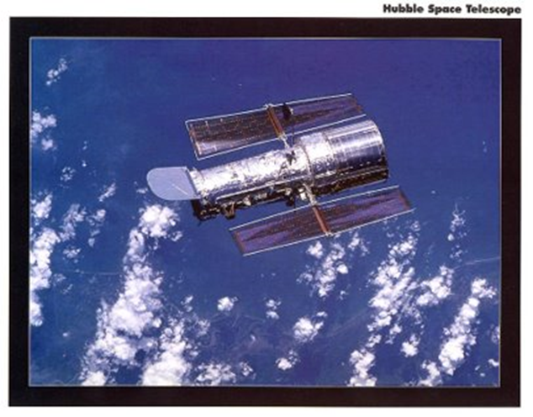

**Figure 1.3.** Hubble Space Telescope

Source: © xxxxxxxxx. Please indicate the exact source from where the image was reproduced.

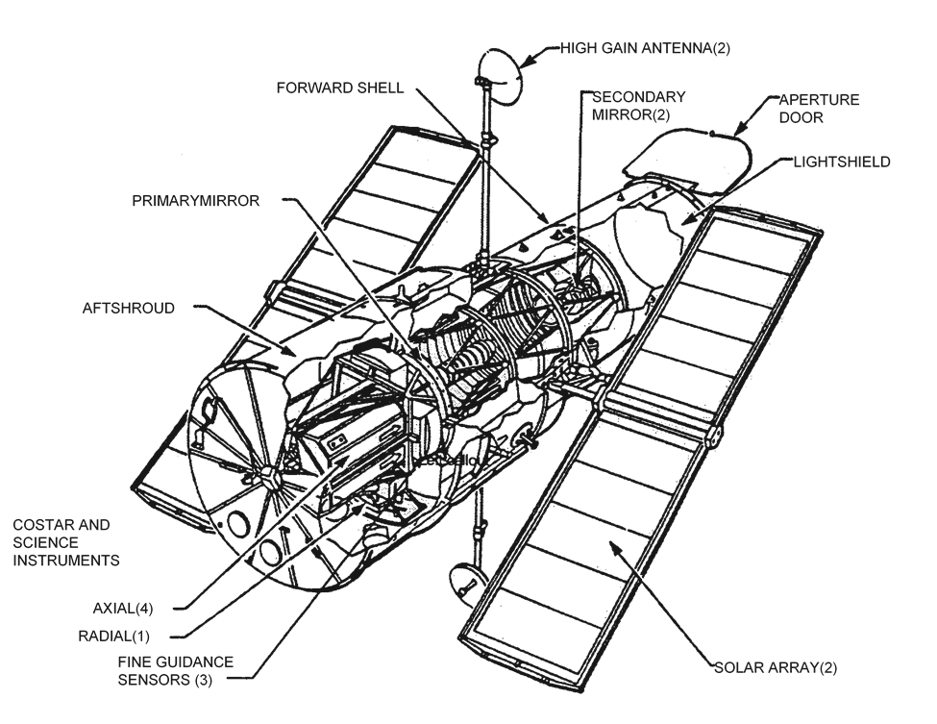

**Figure 1.4.** Hubble Space Telescope Configuration

Source: © xxxxxxxxx. Please indicate the exact source from where the image was reproduced.

Figure 1.3 shows a picture and Figure 1.4 configuration of Hubble Space Telescope.

Since its launch in April 1990, NASA’s Edwin P. Hubble Space Telescope (HST) has continued this historic quest, providing scientific data and photographs of unprecedented resolution from which many new and exciting discoveries have been made.

This unique observatory operates around the clock above the Earth’s atmosphere to gather information for teams of scientists studying virtually all the constituents of our universe, including planets, stars, star-forming regions of the Milky Way galaxy, distant galaxies and quasars, and the tenuous hydrogen gas lying between the galaxies.

The major elements of HST are Optical Telescope Assembly, Science instruments, Support System Module and Solar arrays. HST sensor operates in ultraviolet light, visible light, and infrared light with wavelength 100 nm to 1.8 micron. The main parameters are:

Launch Date: April 1990

Launch Vehicle: Space Shuttle Discovery

Mission Duration: 15 years

Total payload mass: 11,110 kg

Optical system: Ritchey-Chretien design Cassegrain telescope

Primary mirror 94.5 in. (2.4 m) in diameter Secondary mirror 12.2 in. (0.3 m) in diameter

Optical resolution: 0.043 arc second (0.00001Deg)

Orbit: 320-mile (593 km) altitude, inclined 28.5 degrees from equator

Orbit time: Orbit time - 97 minutes per orbit

Pointing accuracy: 0.012 arc-sec (0.000003 deg), 3-Axis stabilized, zero momentum biased control system using reaction wheels.

Pointing stability: 0.007 arc. Sec.

Cost: $2 billion

**MISSION**

The Hubble Space Telescope (HST) is the first observatory designed for extensive maintenance and refurbishment in orbit. The Discovery cargo bay is equipped with several devices to help the astronauts: the Flight Support System (FSS) to berth and rotate the Telescope; large, specially designed equipment containers to house the Orbital Replacement Units (ORUs); and a remote manipulator arm from which astronauts can work and be maneuvered as needed.

After Hubble's deployment in 1990, scientists realized that the telescope's primary mirror had a flaw called spherical aberration. thickness of a human hair). The outer edge of the mirror was ground too flat by a depth of 2.2 microns (roughly equal to one-fiftieth the This aberration resulted in images that were fuzzy because some of the light from the objects being studied was being scattered. COSTAR (the Corrective Optics Space Telescope Axial Replacement) was developed as an effective means of countering the effects of the flawed shape of the mirror. COSTAR was a telephone booth-sized instrument which placed five pairs of corrective mirrors, some as small as a nickel coin, in front of the Faint Object Camera, the Faint Object Spectrograph and the Goddard High Resolution Spectrograph. Servicing Mission 1, launched in December 1993, was the first opportunity to conduct planned maintenance on the telescope. In addition, new instruments were installed and the optics of the flaw in Hubble's primary mirror was corrected.

On November 13, 1999, the Hubble Space Telescope was placed into safe mode after the failure of a fourth gyroscope. In safe mode Hubble could not observe targets, but its safety was preserved. This protective mode allows ground control of the telescope, but with only two gyros working, Hubble cannot be aimed with the precision necessary for scientific observations of the sky. Controllers closed the aperture door to protect the optics and aligned the spacecraft to ensure that Hubble’s solar panels would receive adequate power from the Sun. In servicing mission 3A, December 19-27, 1999, astronauts replaced all six gyroscopes.

In servicing mission 3B, March 1-12, 2022, astronauts replaced flexible, 8 years old, solar array panels with smaller, rigid ones that produced 30% more power and improved pointing accuracy to eliminate control and structures interaction. The pointing stability requirements of 0.07 arc sec was achieved by changing flexible solar array to rigid solar array to avoid structural and control interactions and changing control design.

The above discussion shows how tight requirements are to meet the mission. The surface error in primary mirror of 2.2 microns (roughly equal to one-fiftieth the thickness of a human hair) resulted in images to be fuzzy. The failure of one gyroscope resulted in failure of the pointing system. To meet pointing stability requirements of 0.07 arc sec, solar array must be changed from flexible to rigid to avoid structural and control interactions and new control design. These problems were resolved by satellite servicing missions by astronauts. In the absence of servicing missions, HST, $2B program, would have been a failure.

**James Webb Space telescope (JWST)**

JWST is the scientific successor to Hubble; its science goals were motivated by results from Hubble. JWST looks at the Universe in the infrared, while Hubble studies it primarily at optical and ultraviolet wavelengths (though it has some infrared capability). Hubble's science pushed us to look to longer wavelengths to "go beyond" what Hubble has already done. In particular, more distant objects are more highly redshifted, and their light is pushed from the UV and optical into the near infrared. Thus, observations of these distant objects (like the first galaxies formed in the Universe, for example) require an infrared telescope. Stars and planets that are just forming lie hidden behind cocoons of dust that absorb visible light. However, infrared light emitted by these regions can penetrate this dusty shroud and reveal what is inside. Difference between visible and infrared images is clear from the following two images of Monkey Head Nebula, a star forming region, taken by HST. Left is visible and right is infrared.

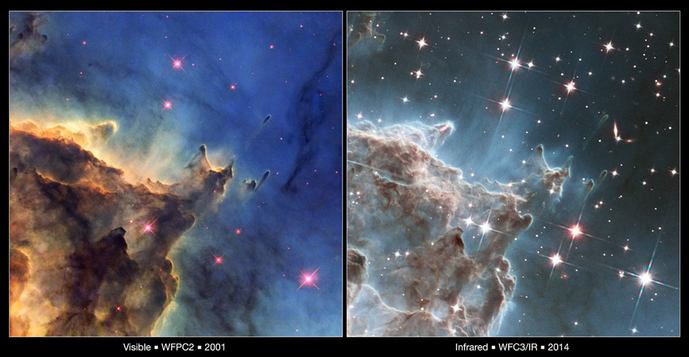

**Figure 1.5** Hubble ‘s Visible and Infrared Views of Monkey Head nebula

Source: © xxxxxxxxx. Please indicate the exact source from where the image was reproduced.

A jet of material from a newly forming star is visible in one of the pillars, just above and left of center in the right-hand image. Several galaxies are seen in the infrared view, much more distinct than the columns of dust and gas.

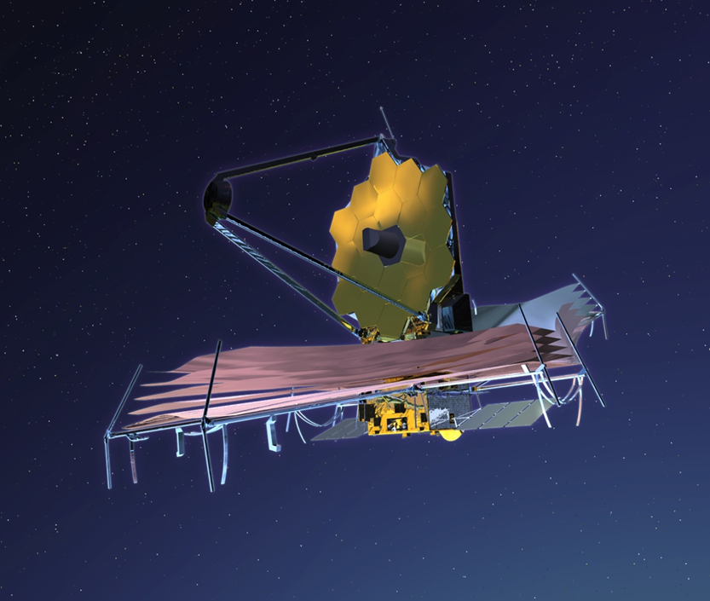

**Figure1.6** James Webb Telescope

Source: © xxxxxxxxx. Please indicate the exact source from where the image was reproduced.

Main parameters of JWST are as follows:

Launch Date: December 24, 21

Launch Vehicle: Ariane5

Mission Duration: 5 - 10 years

Total payload mass: 6200 kg

Diameter of primary Mirror: 6.5 m

Optical resolution: ~3 milliarcseconds (0.0000008 degrees)

Wavelength coverage: 0.6 - 28 microns

Size of sun shield: 22 m x 10 m

Orbit: 1.5 million km from Earth at L2 points

Cost: $10 Billion

JWST's primary mirror is a 6.5 m (21 ft)-diameter gold-coated beryllium reflector with a collecting area of 25.4 m2 (273 sq ft). If it were built as a single large mirror, this would have been too large for existing launch vehicles. The mirror is therefore composed of eighteen hexagonal segments which will unfold after the telescope is launched. Image plane wavefront sensing through phase retrieval is used to position the mirror segments in the correct location using very precise micro-motors. After this initial configuration, they will only need occasional updates every few days to retain optimal focus. The Webb telescope will use 126 small motors to occasionally adjust the optics as there are only few environmental disturbances of a telescope in space. JWST's optical design is a three-mirror anastigmat,[43] which makes use of curved secondary and tertiary mirrors to deliver images that are free from optical aberrations over a wide field. In addition, there is a fine steering mirror which can adjust its position many times per second to provide image stabilization.

A three-mirror anastigmat is an anastigmat telescope built with three curved mirrors, enabling it to minimize all three main optical aberrations – spherical aberration, coma, and astigmatism. This is primarily used to enable wide fields of view, much larger than possible with telescopes with just one or two curved surfaces. A telescope with only one curved mirror, such as a Newtonian telescope, will always have aberrations. If the mirror is spherical, it will suffer from spherical aberration. If the mirror is made parabolic, to correct the spherical aberration, then it must necessarily suffer from coma and off-axis astigmatism. With two curved mirrors, such as the Ritchey–Chrétien telescope, coma can be minimized as well. This allows a larger useful field of view, and the remaining astigmatism is symmetrical around the distorted objects, allowing astrometry across the wide field of view. However, astigmatism can be reduced by including a third curved optical element. When this element is a mirror, the result is a three-mirror anastigmat. In practice, the design may also include any number of flat fold mirrors, used to bend the optical path into more convenient configurations.

To make observations in the infrared spectrum, JWST must be kept under 50 K (−223.2 °C; −369.7 °F); otherwise, infrared radiation from the telescope itself would overwhelm its instruments. It therefore uses a large sunshield to block light and heat from the Sun, Earth, and Moon, and its position near the Sun-Earth L2 always keeps all three bodies on the same side of the spacecraft. Its halo orbit around the L2 point avoids the shadow of the Earth and Moon, maintaining a constant environment for the sunshield and solar arrays. The shielding maintains a stable temperature for the structures on the dark side, which is critical to maintaining precise alignment of the primary mirror segments in space. The temperature of Mid-InfraRed Instrument (MIRI), operating in the range of 5 to 27 micrometers, temperature must not exceed 6 K. It is maintained by cryocooler.

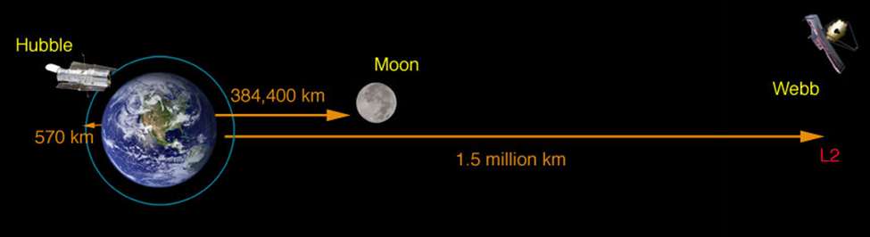

**Figure 1.7** Orbit of James Webb Space telescope

Source: © xxxxxxxxx. Please indicate the exact source from where the image was reproduced.

Webb will orbit the sun 1.5 million kilometers (1 million miles) away from the Earth at what is called the second Lagrange point or L2. (Note that these graphics are not to scale.)

Because Hubble is in Earth orbit, it was able to be launched into space by the space shuttle. Webb was launched on an Ariane 5 rocket and because it won't be in Earth orbit and it is not designed to be serviced by the space shuttle.

**1.2.2 Ground Telescope**

**Keck Telescope**

The most powerful [telescope](https://www.schoolsobservatory.org/learn/eng/tels) on the summit on Mauna Kea is the twin Keck observatory, which has two 10-meter diameter mirrors. At the heart of each Keck Telescope is a revolutionary primary mirror made up of thirty-six hexagonal segments that effectively work as a single piece of reflective glass. By combining advanced optical and [infrared](https://www.schoolsobservatory.org/learn/science/waves/light/emspec) detectors with sophisticated electronics that can combine collected light from both telescopes, the Keck observatory remains amongst the leading astronomical facilities in the world.

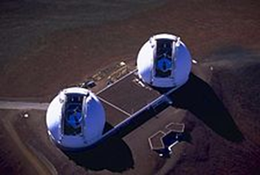

**Figure 1.8** Keck Telescope

 Source: © xxxxxxxxx. Please indicate the exact source from where the image was reproduced.

Some facts about the telescope: Observatory location: Mauna Kea, Hawaii; Height above sea level: 4,145 meters (13,790 feet); Moving Mass: 270 metric tons (each); Mirror diameter: 10.0 meter (each); Distinctive feature: Each mirror has thirty-six hexagonal segments.

Each mirror segment is kept stable by a system of active optics that adjusts its position, relative to adjacent segments, to an accuracy of four nanometers. This twice-per-second adjustment corrects any distortions due to [gravity](https://www.schoolsobservatory.org/learn/science/fandm/gravity). Both telescopes are also equipped with adaptive optics, which compensates for the [blurring](https://www.schoolsobservatory.org/learn/astro/nightsky/pollution/seeing) caused by turbulence in the atmosphere. This, combined with the light collecting power of two sizeable mirrors, and some pretty sophisticated [instrumentation](https://www.schoolsobservatory.org/learn/tech/instruments), means that the twin Keck telescopes can produce some incredibly detailed images of distant objects in the [Solar System](https://www.schoolsobservatory.org/learn/astro/solsys), that are almost on a par with images from [space telescopes](https://www.schoolsobservatory.org/learn/eng/tels/spacetel). The following are two good examples of what Keck can do:

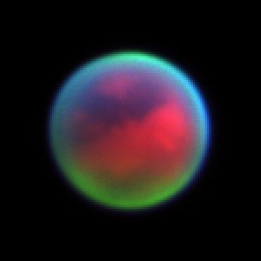

**Figure 1.9** Saturn's largest moon - Titan

Source: © xxxxxxxxx. Please indicate the exact source from where the image was reproduced.

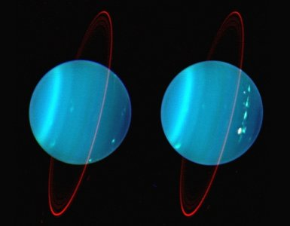

**Figure 1.10.** Images showing the two sides of Uranus.

Source: © xxxxxxxxx. Please indicate the exact source from where the image was reproduced.

[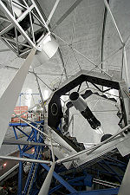](https://en.wikipedia.org/wiki/File:KeckObservatory20071013.jpg)

**Figure 1.11**. The Keck II telescope showing the [segmented](https://en.wikipedia.org/wiki/Segmented_mirror) primary mirror

Source: © xxxxxxxxx. Please indicate the exact source from where the image was reproduced.

The key advance that allowed the construction of the Keck telescopes was the use of [active optics](https://en.wikipedia.org/wiki/Active_optics) to operate smaller [mirror segments](https://en.wikipedia.org/wiki/Segmented_mirror) as a single, contiguous mirror. A mirror of comparable size cast of a single piece of glass could not be made rigid enough to hold its shape precisely; it would sag microscopically under its own weight as it was turned to various positions, causing aberrations in the optical path. In the Keck telescopes, each primary mirror is made of thirty-six hexagonal segments that work together as a unit. Each segment is 1.8 meters wide, 7.5 centimeters thick, and weighs half a ton.[[2]](https://en.wikipedia.org/wiki/W._M._Keck_Observatory#cite_note-2) The mirrors were made from [Zerodur](https://en.wikipedia.org/wiki/Zerodur) [glass-ceramic](https://en.wikipedia.org/wiki/Glass-ceramic) by the German company [Schott AG](https://en.wikipedia.org/wiki/Schott_AG). On the telescope, each segment is kept stable by a system of [active optics](https://en.wikipedia.org/wiki/Active_optics), which uses extremely rigid support structures in combination with three actuators under each segment. During observation, the computer-controlled system of sensors and actuators dynamically adjusts each segment's position relative to its neighbors, keeping a surface shape accuracy of four [nanometers](https://en.wikipedia.org/wiki/Nanometer). As the telescope moves, this twice-per-second adjustment counters the effects of gravity and other environmental and structural effects that can affect mirror shape.

Both Keck Observatory telescopes are equipped with [laser guide star](https://en.wikipedia.org/wiki/Laser_guide_star) [adaptive optics](https://en.wikipedia.org/wiki/Adaptive_optics), which compensates for the blurring due to [atmospheric turbulence](https://en.wikipedia.org/wiki/Astronomical_seeing). The first AO system operational on a large telescope, the equipment has been constantly upgraded to expand the capability. The telescopes are equipped with a suite of cameras and spectrometers that allow observations across much of the visible and near infrared spectrum.

**1.3 Laser Systems**

Laser Systems can be divided into two groups: low power systems and high-power systems.

Low power laser systems are used for commercial and civilian applications, such as laser communications. High power laser systems are normally used for military applications.

**1.3.1 High Power Laser Systems**

**Air Born Laser System**

The Air Born Laser (ABL) system, as shown in Fig. 1.12, was high power laser system. The ABL was designed to detect and destroy theatre ballistic missiles in the powered boost phase of flight immediately after missile launch while the aircraft loiters at an altitude of 40,000ft.

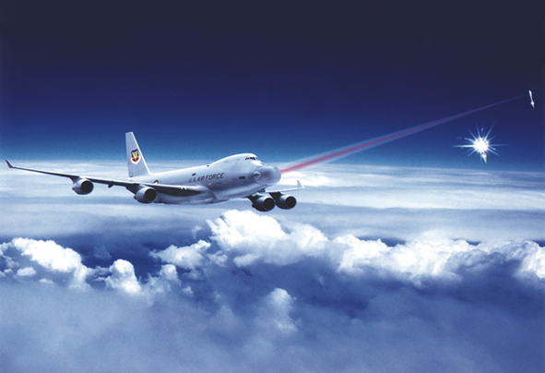

**Figure 1.12**. Air Born laser System

Source: © xxxxxxxxx. Please indicate the exact source from where the image was reproduced.

It was developed for the US Air Force), designated YAL-1A, was a high-energy laser weapon system for the destruction of tactical theatre ballistic missiles, which is carried on a modified Boeing 747-400F freighter aircraft. The ABL was developed by the Air Force Research Laboratory and ABL Team, comprising Boeing, TRW (now Northrop Grumman Space Technologies) and Lockheed Martin. The ABL aircraft carries the COIL laser which generates the killer laser beam, an infrared surveillance and high-speed target acquisition system and a high precision laser target tracking beam control system. The missile plume is detected by the ABL aircraft's infrared detection system at ranges up to several hundred kilometers.

The laser weapon uses three laser beam systems: the powerful killing laser beam or primary beam, a set of illuminating laser beams and a beacon laser. The primary laser beam is generated by a megawatt chemical oxygen iodine laser (COIL) located at the rear of the fuselage, which lases at 1.315-micron wavelength. The high-power laser beam travels towards the front of the aircraft through a pipe. The pipe passes through a Station 1000 bulkhead / airlock, which separates the rear fuselage from the forward cabins. The high-power beam passes through the fine beam control system mounted on a vibration isolated optical bench. Beam pointing is achieved with fast, lightweight steering mirrors, which are tilted to follow the target missile.

A low-power, multiple beams, track illuminating laser (TILL), being developed by Raytheon Electronic Systems, is used to determine the target’s range, and provides initial information on the atmosphere through which the beam is being transmitted. The illuminating laser tracks the target and provides aiming data for the primary beam. The beacon illuminating laser (BILL) has been developed by Northrop Grumman Space Technology. The kilowatt class BILL reflects light from the target to provide data on the rapidly changing characteristics of the atmosphere along the path of the laser beam. This data is used to control a set of deformable mirrors in the beam control system. The mirrors introduce tailored distortions into the COIL laser beam to compensate for atmospheric distortions and allow the COIL laser beam to fall on the target with full power.

A suite of infrared, wide-field telescopes installed along the length of the aircraft’s fuselage detects the missile plume at ranges up to several hundred kilometers. The pointing and tracking system track the missile and provides launch and predicted impact locations. The turret at the nose of the aircraft swivels towards the target and a 1.5m telescope mirror system inside the nose focuses the laser beam onto the missile. The laser beam locks onto the missile, which is destroyed near its launch area within seconds of lock-on. Where the missile carries liquid fuel, the laser can heat a spot on the missile’s fuel tank, causing an increase in internal pressure resulting in catastrophic failure. Alternatively, the missile is heated in an arc around its circumference and crumples under atmospheric drag force or its own g-force.

On February 11, 2010, in a test at Point Mugu Naval Air Warfare Center-Weapons Division Sea Range off the central California coast, the system successfully destroyed a liquid-fuel boosting ballistic missile. Less than an hour after that first missile had been destroyed, a second missile—a solid-fuel design—had, as announced by the MDA, been "successfully engaged", but not destroyed, and that all test criteria had been met. This test was the first time that a directed-energy system destroyed a ballistic missile in any phase of flight. It was later reported that the first February 11 engagement required 50% less dwell time than expected to destroy the missile, the second engagement on the solid-fuel missile, less than an hour later, had to be cut short before it could be destroyed because of a "beam misalignment" problem. In December 2011, it was reported that the project was to be ended after 16 years of development and a cost of over US$5 billion.

Some of the performance requirements for beam control are as follows.



**1.3.2 Low Power laser Systems**

Laser communications is an important application of low power laser systems. Conventional communications systems on ground, air, and space use radio frequency (RF) spectrum for communications. RF spectrum has frequencies from 3 Hz to 3,000 GHX (3THz). Geosynchronous communications satellites have been heavily used for national and international communications since the 1960s. Recently these satellites have capacity of greater than 1 Tbps per satellite. Most used frequency bands are C band 4/6 GHz, Ku band 11/14 GHz, and Ka band 20/30 GHz. Recently several constellations of low earth orbit satellites are planned for internet applications and covering the areas not covered by cables. RF systems are however hindered by the available spectrum bandwidth limitations and regulations.

Laser communication with currently unregulated spectrum and with multi-THZ bandwidth can augment RF systems by providing order of magnitude capacity enhancements. Laser communications systems for visible light the frequencies are 400 THz and 700 THz corresponding to wave lengths 700 nm and 400 nm, respectively. For infrared communications, the frequencies are lower with typical wavelength 850 or 1550 nm. In comparison to RF systems, laser communication systems are in order of magnitude lighter, compact, and low power requirements. There are certain advantages and disadvantages to laser communications. Beam width for laser communications due to high frequency/short wavelength are three to four orders of magnitude narrower than RF communications with lower frequency. This results in some advantages, disadvantages, and challenges. The advantages include wide bandwidth and large data rate, secure communications jam resistance, small antenna, and volume, low wight and power. There are several disadvantages in comparison to RF communications. First are the adverse effects of atmosphere due to clouds and turbulence resulting in deep fades and beam breakups. For high link availability requirements, such as internet, for laser communications through atmosphere downlink and uplink to satellite may not meet requirements. It can be used for applications where timely delivery may not be required. For laser communications, the ground stations are on high mountains to minimize turbulence effect. To minimize turbulence, adaptive optics techniques are used that make ground stations more complex. The second challenge is that due to very narrow laser beam, beam control for acquisition, pointing, tracking, and jitter control is difficult compared to RF communications. For a typical laser system, telescope beamwidths are 3-5 microrad, to mitigate most of pointing loss RMS beam jitter should be less than 30% of beamwidth and pointing accuracy should be at least 0.1 times bam width. Typical spacecraft vibrations and attitude variation are in an order of magnitude higher. Therefore, passive jitter control may be required and pointing control with very accurate sensors are required.

**Laser Communications Relay Demonstration (LCRD)**

Laser communication has been considered and developed for many applications, such as free space optical communications from satellite to satellite. Laser communication has been used by NASA for deep space optical communication as it requires higher data rate than possible with RF systems to support future science data retrieval. As an example, NASA has developed Laser Communications Relay Demonstration (LCRD) to demonstrate laser communications technologies. According to NASA, as science instruments evolve to capture high-definition data like 4K video, missions will need expedited ways to transmit information to Earth. With laser communications, NASA can significantly accelerate the data transfer process and empower more discoveries.

Laser communications will enable 10 to 100 times more data to be transmitted back to Earth than current radio frequency systems. It would take nine weeks to transmit a complete map of Mars back to Earth with current radio frequency systems. With lasers, it would take about nine days. Additionally, laser communications systems are ideal for missions because they need less volume, weight, and power. Less mass means more room for science instruments, and less power means less of a drain of spacecraft power systems. These are all critically important considerations for NASA when designing and developing mission concepts. The following figure shows LCRD communicating data from the space station to Earth.

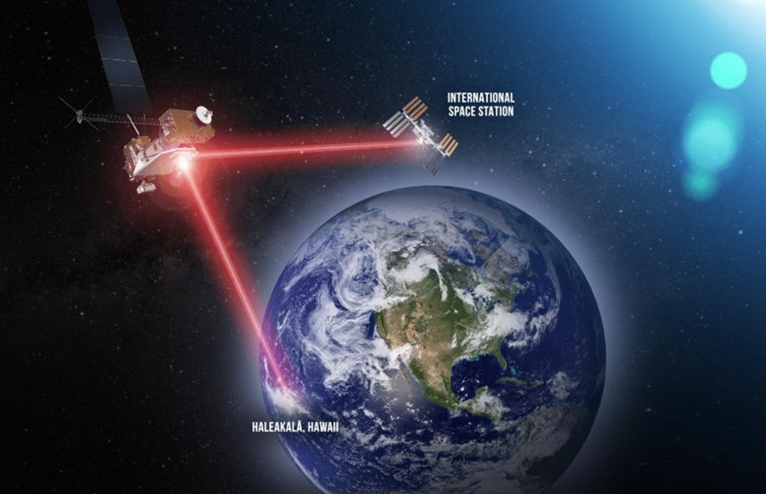

**Figure 1.13** LCRD Operational Configuration

Source: © xxxxxxxxx. Please indicate the exact source from where the image was reproduced.

LCRD’s modems translate digital data into laser signals, which are then transmitted via encoded beams of light, invisible to the human eye, by the relay’s optical modules. LCRD can both send and receive data, creating a continuous path for flowing mission data to-and-from space. Together, these capabilities make LCRD NASA’s first two-way, end-to-end optical relay. Once LCRD receives information and encodes it, the payload sends the data to ground stations on Earth that are each equipped with telescopes to receive the light and modems to translate the encoded light back into digital data. LCRD uses two communication modulations, Differential Phase Shift Keying (DPSK) and Pulse-position modulation (PPM)

LCRD’s ground stations are known as Optical Ground Stations (OGS) -1 and -2, and are located on Table Mountain in Southern California, and on Haleakala Volcano in Maui, Hawaii. While laser communications can provide increased data transfer rates, atmospheric disturbances – such as clouds and turbulence – can interfere with laser signals as they travel through Earth’s atmosphere. The locations for OGS-1 and OSG-2 were chosen for their clear weather conditions and remote, high-altitude locations. Most of the weather occurring in those areas takes place below the summit of the mountains, leaving relatively clear skies perfect for laser communications. Figure 1.4 shows OGS.

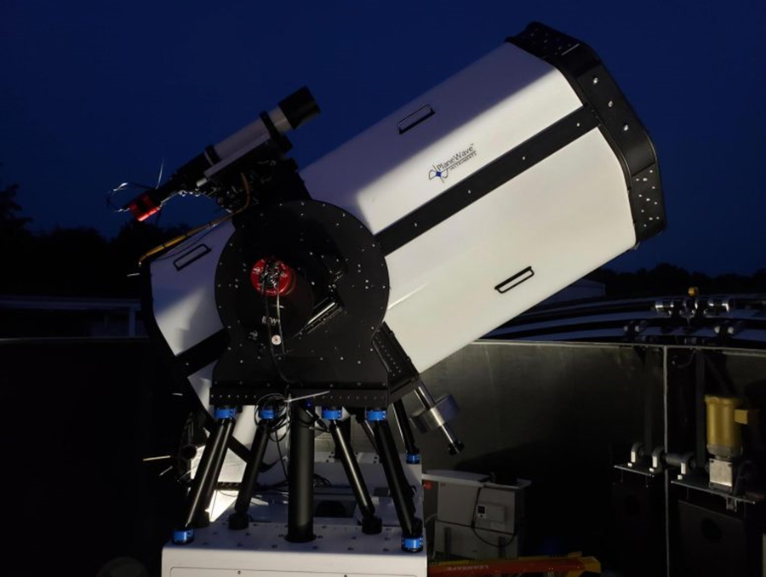

**Figure** 1.14. Add Caption

Source: © xxxxxxxxx. Please indicate the exact source from where the image was reproduced.

The ground stations use adaptive optics techniques to correct aberration in the laser beam due to turbulence.

The important parameters of LCRD payload are as follows:

Wavelength: 1550 nm

Terminal mass: 69 kg

Optical transmit power: 130 W DC

Telescope diameter: 108 mm

Data rates: 2.880 Gbit/s using DPSK, and 622 Mbit/s using PPM.

Launch: Not yet ?, from Cape Canaveral Space Force Station in Florida. The LCRD payload is hosted on the U.S. Department of Defense's STPSat-6 spacecraft, launched aboard a United Launch Alliance Atlas V 551 rocket.

1.4 Optical Beam Control Challenges

As discussed earlier, the challenges for optical control design is perimarily due to small wavelengths. The interest is primarily in visible range, 400-700 nm and near infra-red range 700-1.100 nm. Many performance requiremeent are directly related to its wavelength. For example, for diffraction limited images, the mirror RMS surface error should be less than  where  is wavelength. For visible light at 600 nm, this will require surface accuracy of 20 nm. As an example, as discussed earlier, the outer edge of the Hubble Telescope mirror was ground too flat by a depth of 2.2 microns (roughly the one-fifth of hair thickness). This resulted in fuzzy images due to spherical aberration. This problem was corrected by installing a correcting device by the astronauts. Similarly for a Gaussian beam, the beam width is proportional to the wavelength of light (λ) and inversely proportional to the aperture size. As discussed earlier, typical telescope beam widths are 3-5 microrad. To mitigate most of pointing loss, beam jitter should be less than 30% beam width, resulting in 0.9-1.5 microradian, pointing accuracy should be 0.1 times beam width, resulting in 0.3-0.5 microradian. As discussed earlier, for Hubble Space Telescope, pointing accuracy requirement is 0.012 arc-sec (0.000003 deg) and jitter 0.007 arc. Sec. For laser system, there is additional requirement for laser beam correction due to atmosphere turbulence.

Addressing these challenges often requires a multidisciplinary approach, involving expertise in optics, control systems, stuctures, and thermal engineering. As technology advances, new solutions and innovations continue to emerge to tackle these design challenges in optical beam control systems. In the following chapters, fundamental of these areas related to optical beam control will be covered. In Chapter 2 will focus onoptics. It will cover light source, propagation of lights, lenses and mirrros, wave inteference, diffraction, plarization, and scattering. Chapter 3 will focus on beam fine control. It will cover classical control, modern control, Kalman filter, sensors, actuators, flexible control, slew maneuvers, and acquistion, tracking, and pointing. Chapter 4 will focus on sources of beam aberrations. It will cover vibration and jitter, optical abberations, air turbulence, and measure of optical abberations. Chapter 5 will focus on vibration and jitter control. It will cover vibration isolation and active jitter control. Chapter 6 will focus on adaptive optics. It will cover wavefront sensors, wavefront reconstruction, deformable mirrors, adaptive optics configurations, and adaptive optics control systems. Chapter 7 will focus on imaging satellites. It will cover telescope designs, optical train componenets, image abberation, space teelscopes, ground telescope, and performance analysis. Chapter 8 will focus on laser systems. It will cover laser fundamentals, laser beam control harwares, laser aberation, laser performance, peformance analysis, laser communications systems, and high energy laser systems.